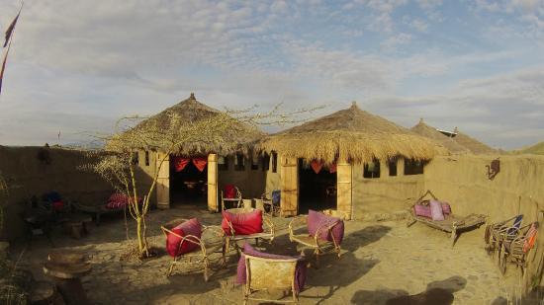
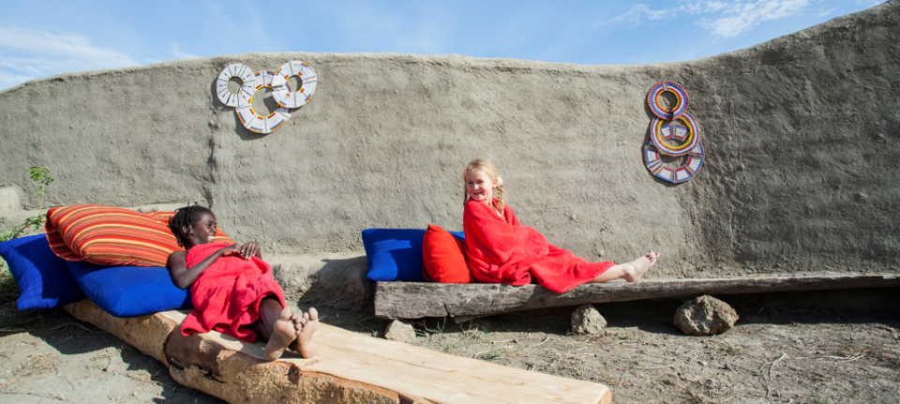
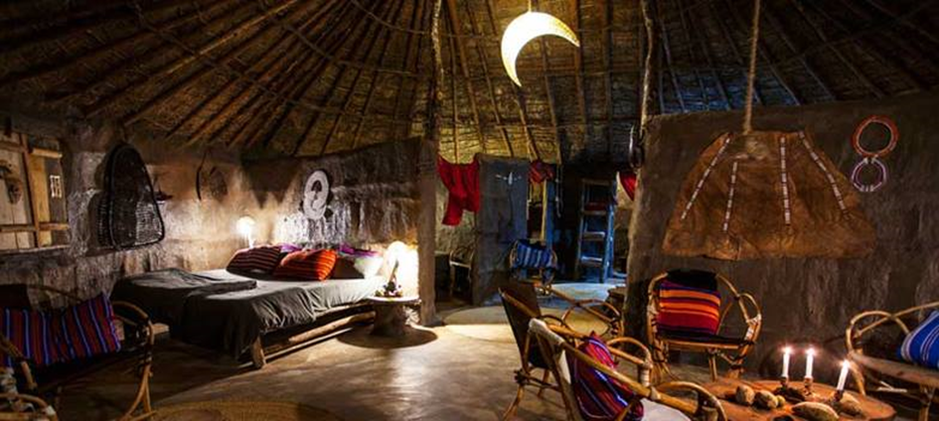

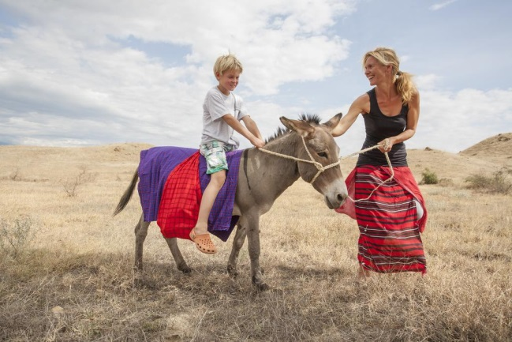
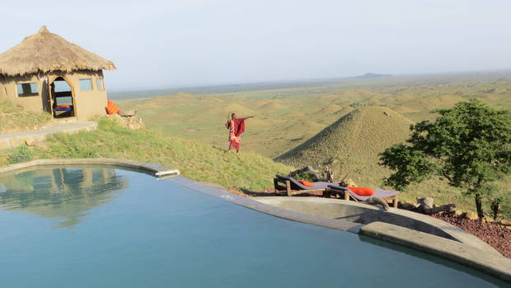
MAASAI LODGE
A special place where you immediately will come to rest and reflect on the essentials. In the middle of the wilderness of the Maasai steppe are seven bungalows with hand crafted furniture with great view on the Kilimanjaro, Africa‘s highest mountain. Behind it and until the border of Kenya there is the savanna, home to the Maasai people. This is the right place to get to know them and their traditions and rituals, together with a slowing-down of your own lives’ pace. It‘s all about being together, traditions, stories and learning from each other.

http://africaaminilife.com/en/locations/

